

AESSEAL Inc
355 Dunavant Drive, Rockford
TN. 37853
Tel: +1 865 531 0192
Fax: +1 865 531 0571
Email: usa@aesseal.com
Web: www.aesseal.com

AESSEAL plc
Global Technology Centre
Mill Close, Rotherham
S60 1BZ
Tel: +44 (0) 1709 369966
Fax: +44 (0) 1709 720788
Email: enquiries@aesseal.info
Web: www.aesseal.com

Steam Turbine Seal Application Form

Please check the dimensional suitability of my application. - Complete sections 1, 2 and 3

Non Detachable or Non Bolt-on Seal Chamber - Complete sections 4

SECTION 1: Customer Details

Is this application for the Oil & Gas or Petrochemical Industry? | Yes | No
System quote also required? (Attach systems application form) | Yes | No

API information required (Mandatory)

End User:

Industry Sector:
Location:
Area of Plant:
Duty:
.
Company: |  | Phone no:
Engineer: |  | Email:

SECTION 2: Seal Dimensional Details - Detachable Seal Chamber

2.1 Standard Bolt on Seal Housing

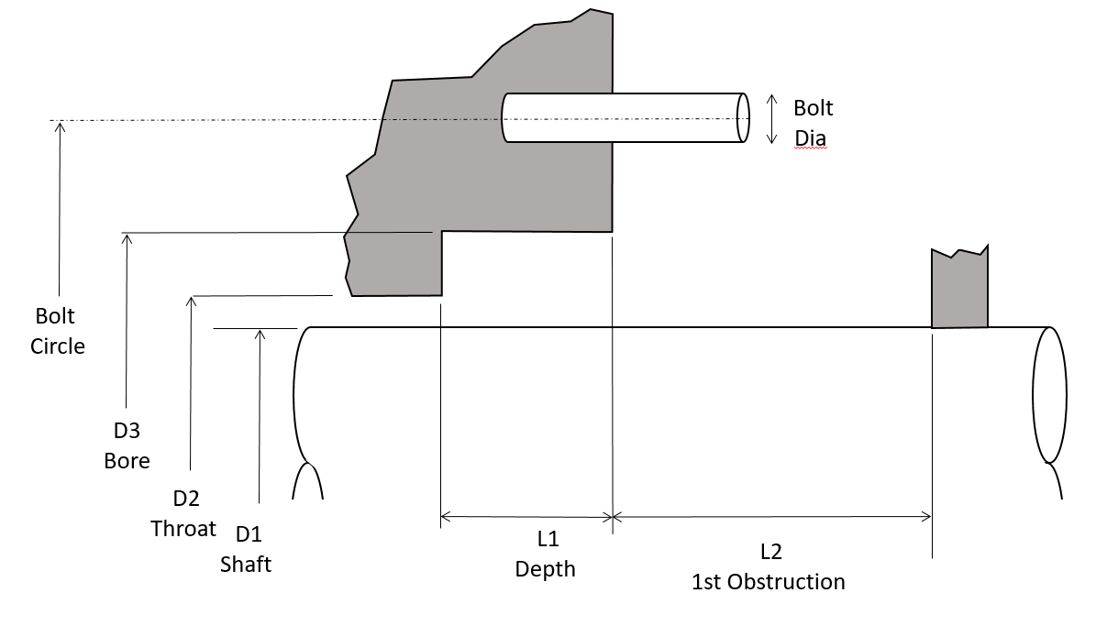
 |  | D1: |  | inches
 |  | D2: |  | inches
 |  | D3: |  | inches
 |  | Bolt Circle: |  | inches
 |  | L1: |  | inches
 |  | L2: |  | inches
 |  | Max. Gland O/D: |  | inches
 |  | Bolt No:
 |  | Bolt Equi Spaced?: | Yes | No
Is the shaft hardness >35 Rc?: |  |  | Yes | No
If yes state value or material spec:

- CAUTION:
- Steam Turbine Seals are generally fitted to replace carbon bushings. Hard shaft coatings or plating previously applied for wear resistance against carbon bushings need removing in the seal area. Shaft hardness in seal area must be <35Rc for standard set-screw drive.
- Completeness and accuracy of Bolt Spacing and PCD details is critically important for seal design and fitment. Steam turbine housing designs often do not have equi-spaced bolt patterns and/or common PCDs. Complete section 2.2 with as much detail as possible whenever this is the case.

2.2 Bolt Patern / Orientation When Viewed From Bearing

If bolt pattern is not equi-spaced detail below
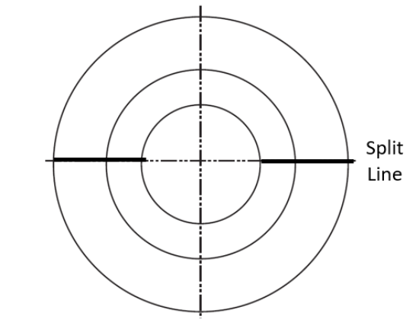

Additional Notes: | If more than 1 stage supply cross section drawing as an attachment  Please state units, e.g. psia, psig, barg, inches, mm

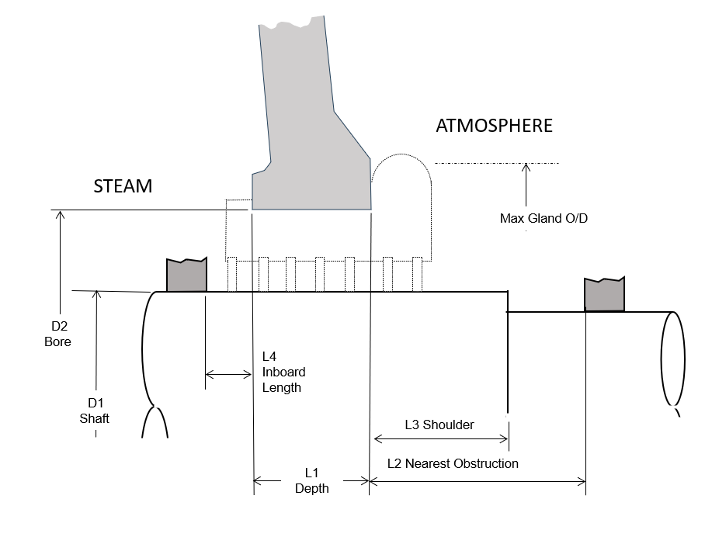
2.3 Alternative Housing - Integral with Replaceable Housing

D1: |  | inches
D2: |  | inches
:
L1: |  | inches
L2: |  | inches
L3: |  | inches
L4: |  | inches
Max. Gland O/D: |  | inches
:
Is the shaft hardness >35 Rc?: | Yes |  | No
If yes state value or material spec:

2.4 Alternative Housing - Integral Housing
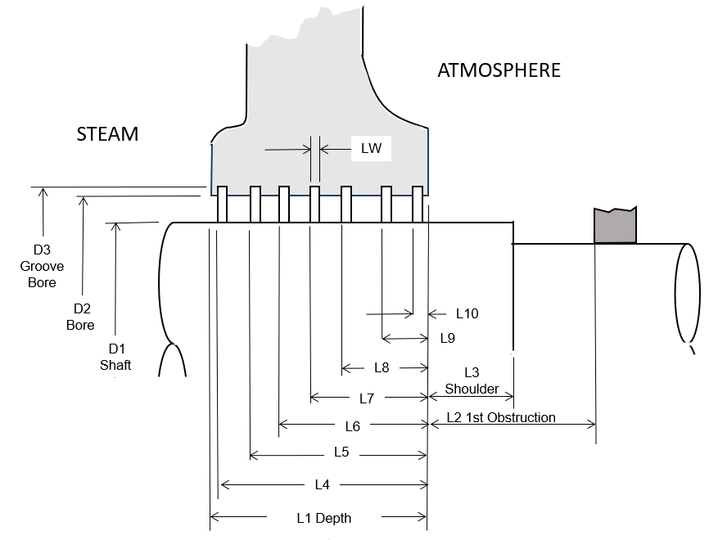

D1: |  | inches
D2: |  | inches
D3: |  | inches
L1 Depth: |  | inches
L2 1st Obstruction: |  | inches
L3 Shaft Shoulder: |  | inches
LW: |  | inches
L4: |  | inches
L5: |  | inches
L6: |  | inches
L7: |  | inches
L8: |  | inches
L9: |  | inches
L10: |  | inches
Is the shaft hardness >35 Rc?: | Yes |  | No
If yes state value or material spec:

SECTION 3: Steam Turbine Details

Manufacturer: |  | Size / Model / Type:
Serial No: |  | Shaft Speed (rpm):
Direction of Rotation: | CW (Clockwise) |  | CCW (Counter-Clockwise)
Direction of Rotation: | ^^^direction as viewed from coupling end^^^
Tag Number: |  | No Of Stages:
Radial Movement (max): |  | Axial Movement (max):
Inlet Pressure: |  | Inlet Temperature:
Exhaust Pressure: |  | Exhaust Temperature:
No Of Seals: |  | Trip Speed:
Additional Notes: | If more than 1 stage supply cross section drawing  Please state units, e.g. psia, psig, barg, inches, mm

SECTION 4: Non Detachable or Non Bolt-on Seal Chamber

Essential: | Information for non-Standard Designs – to aid in a technical and commercial evaluation by AESSEAL® management. Please provide full dimensional information and sketch.
Additional Notes: | If more than 1 stage supply cross section drawing  Please state units, e.g. psia, psig, barg, inches, mm

SECTION 5: Commercial Details

Target List Price:
Estimated Order Date:
Estimated Delivery Date Required:
Estimated % Chance of Customer Order Win: | %
Estimated % Chance of AESSEAL Order Win: | %

Additional information as required

